Circuit Diagram:

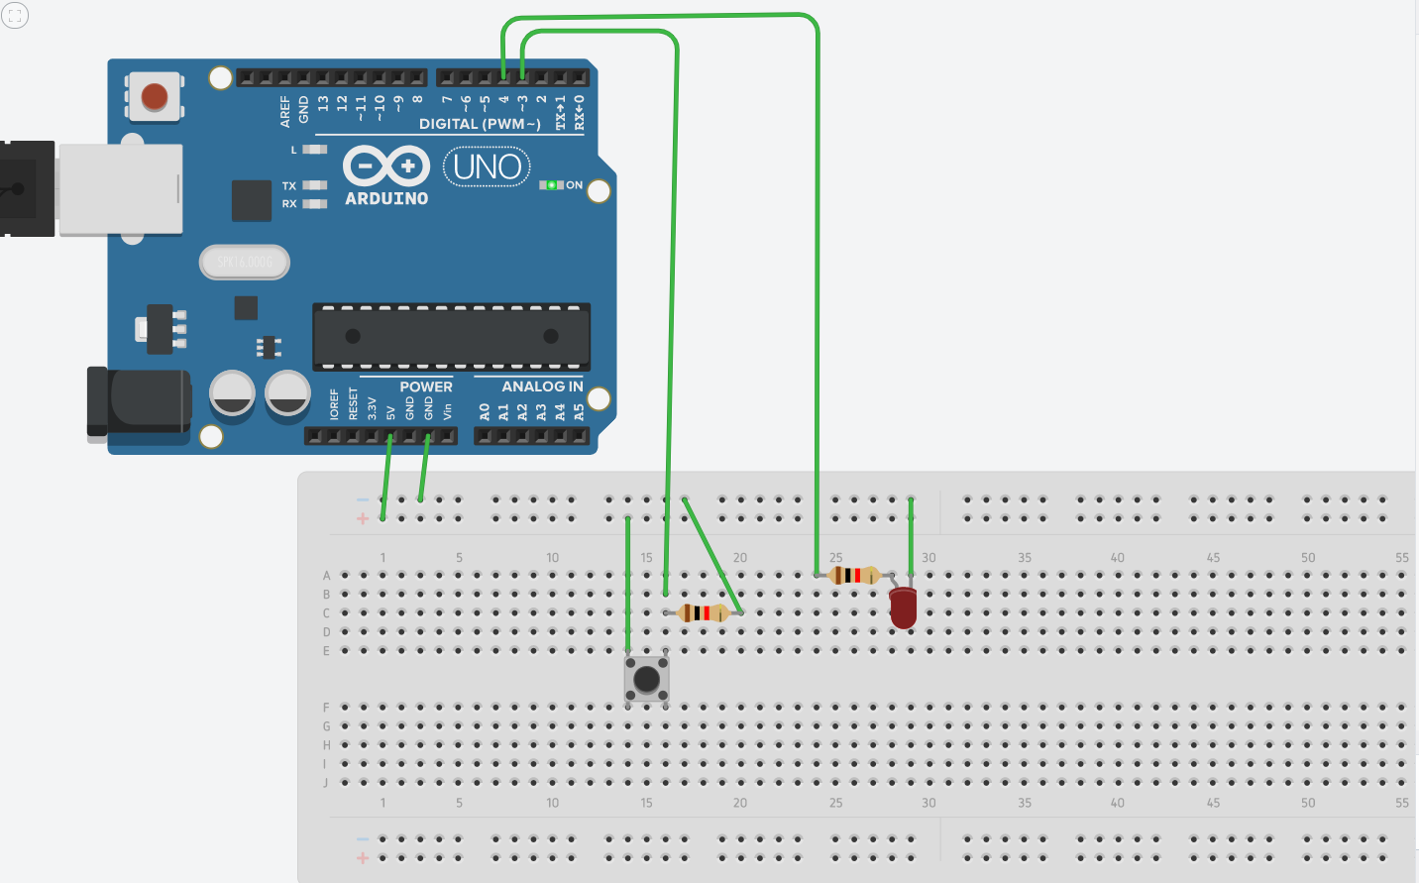

Theory:

Concept Used:

1)I used concept of how touse P-N junction diode.

2) How resistance is used in a circuit.

3) Logic code for Arduino UNO, using Loop statement.

4) How to work with Breadboard.

Learning & Observations:

**Learning:**

1)I learnt to use Arduino Board and how to code it for push button

2)Arduino board has Digital pins and Analog pins.

Digital pin provides Input as well as Output, but Analog pin provides input only.

3)The Arduino board has ~ sign in Digital pin side which is also known as Pulse Width Modulation(PWM).

These pins help’s in getting analog results with digital means.

4)How to work with cuircts on breadboard.

5)Since the LED can bear a limited supply of voltage so we have used resistance in series

It can not work with 5V.

6. Digital Pin provides 5V Power supply to the circuit.

**Observations:**

1)The Arduino board can provide a supply of 5V to the chaser circuit.

2)I connected the ‘p’ terminal of the p-n junction diodes to the Digital pins 5,6,7,8 in combination with the resistance, and ‘n’ terminals with the ground(GND).

3)After uploading the code on the Arduino software, when push button is pressed ,light turns onn,

it turns off when it is not pressed.

Problems and Troubleshooting:

1)The circuit on the bread board is not relevant so the circuit will not work.

I have fixed it by recognizing the circuit properly and again make the circuit on the board.

2)We should also connect read pin to ground when it is not in use.

Precaution:

1)We need to handle the elements of the device with good care.

2)The connections on the Arduino board must coincide with the codes written on the software.

3)During the writing of the codes, the insertion of delay should not be forgotten.

4)In the IDE of Arduino the instructions should be given only in void loop section.

Learning and Outcomes:

1)I have learnt to make circuits using breadboard, Arduino board and other equipment.

2)I have learnt how Arduino can be used in various conditions.

3)I have learnt that what are the elements of Arduino board and how they function.

4)I have learnt how a Push button works.